INTRODUCTION:
Elastic design method limits the usefulness to the allowable stress of the material, which is well below the elastic limit. In plastic design method, the ultimate load is regarded as the design criterion. Plastic design method is rapid and provides a rational approach for the analysis. Plastic design method can be easily applied in the analysis and design of statically indeterminate framed structures.
DEFINITION:
Plastic hinge: a yielded zone at which an infinite rotation can take place at a constant plastic moment. Theoretically, a plastic hinge is assumed to form at a point of plastic rotation. There is a constant moment at the Plastic hinge, with a value equal to Plastic moment Capacity of the cross section.

PART – 2
ANIMATION STEPS
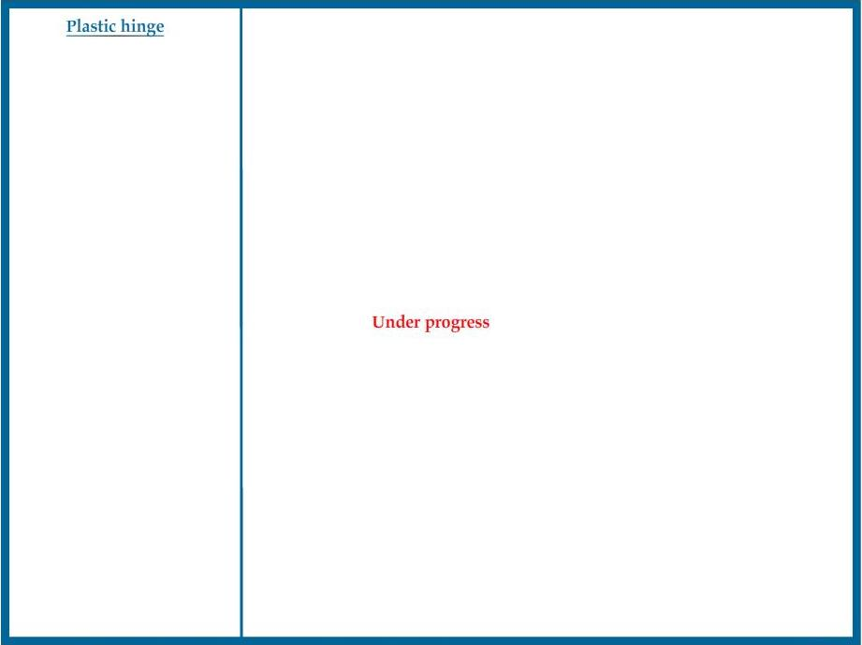

PART – 3
VIRTUAL LAB FRAME

